LKS Current Awareness Bulletin
Bereavement March/May 2019

A current awareness update service from Library and Knowledge Services. If you know anyone who could benefit from receiving this please ask them to sign up by emailing abbas.bismillah@elht.nhs.uk or library.blackburn@elht.nhs.uk

Welcome to the National Bereavement Care Pathway
Prime Minister urges all NHS Trusts to adopt the National Bereavement Care Pathway.
National Bereavement Care Pathway

Sonographers and the National Bereavement Care Pathway
A project to improve the overall quality of bereavement care for parents and families whose baby has died before, during or shortly after birth, is being extended to include 21 more NHS trusts across England, in addition to the 11 which pioneered the programme. "Sonographers should be aware of their role in the National Bereavement Care Pathways," according to Nigel Thomson, the Society's professional officer for ultrasound.
The Society of Radiographers

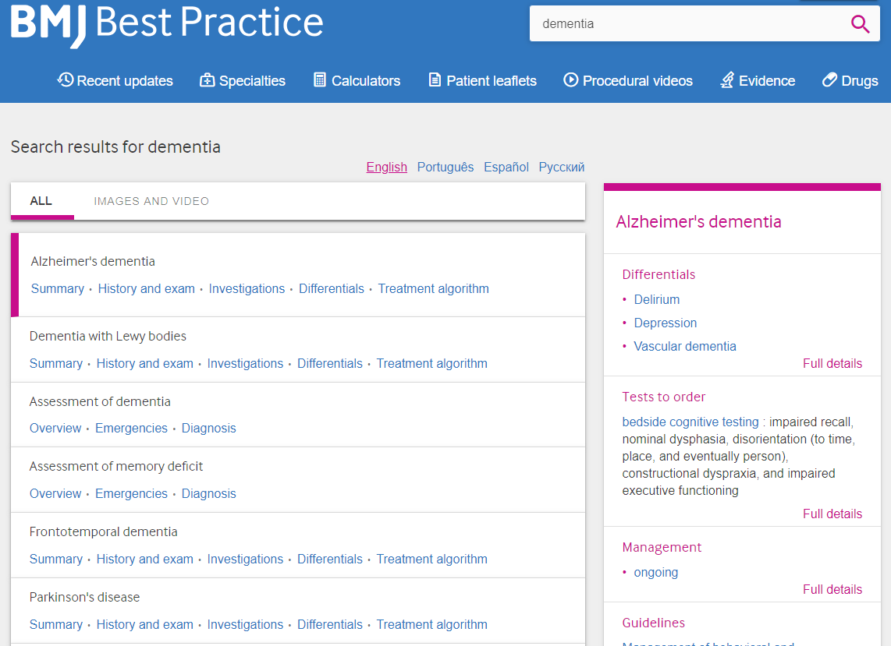
BMJ Best Practice is a decision-support tool published by the BMJ Group and is a single source of evidence based medicine, which combines the latest research evidence, guidelines and expert opinion – providing essential learning on prevention, diagnosis, treatment and prognosis. BMJ Best Practice is of use to all staff - Doctors, Nurses and Midwives, HCAs, Patients, Volunteers, Admin.
The website also has a CME/CPD activity tracking tool which logs your searches and active hours and allows users to create activity certificates to support revalidation and CME/CPD. If you don’t know how to use BMJ Best Practice, then please book a training session with the library team.

For references where there is a link to the full text please use your NHS Athens username & password to access https://openathens.nice.org.uk/

Improving quality of dying: What makes a ‘good death’?
Where do nurses go for help? A qualitative study of coping with death and dying
Raising awareness that dying matters
Paradoxes of death and dying
Conversations with families about reducing the risk of sudden infant deathsyndrome
Attitudes and perceptions of paramedics about end-of-life care: a literature review
Suicide and self-harm: vulnerable children and young people
Bereavement midwife Christa Burgess receives Cavell Star
Care after death
Our crucial journey in end-of-life care
Managing common end-of-life cancer presentations according to the evidence
Pioneering end-of-life care at London Ambulance Service
Are district nurses well placed to provide equitable end-of-life care to individuals who are homeless?
Shifting perspectives in palliative and end-of-life care: a personal view
Dignity in life and care: the perspectives of Swedish patients in a palliative care context

BMJ Learning FREE learning modules for ALL staff and students at ELHT
Hundreds of relevant interactive CPD courses @BMJLearning to choose; a great way to get your #CPD points for #Revalidation BMJ Learning is an e-learning platform for healthcare students and professionals, providing high-quality, evidence-based, and continuing medical education.
Primary Care | Stay up-to-date with 600+ clinical and non-clinical modules for GPs and other primary care staff
Specialist | Stay up-to-date with 700+ modules from 10 specialist journals
Medical Trainees | Curriculum based modules on common presentations, procedures and skills
Surgical Trainees | Support your training with interactive modules using 3D animation to demonstrate surgical skills
Students | Helping you prepare for clinical practice with training in common cases and skills
Nurses | Stay up-to-date with clinical and non-clinical topics for primary care, secondary care, and specialist nurses
Pharmacists | Stay up-to-date 100+ modules from Drug and Therapeutics Bulletin

You’ll need an OpenAthens account to access https://openathens.nice.org.uk/
We can show you how you too can access these resources and more. To book a session, please contact, Abbas Bismillah, Library and Knowledge Services Manager on ext. 84308 or email abbas.bismillah@elht.nhs.uk

Visit our website for further information of the many services that we provide.

Twitter News
https://twitter.com/DyingMatters/status/1134093369834188801
Nurses struggling to look after dying patients due of staff shortages, survey finds

Recording the precious stories of the dying
https://twitter.com/DyingMatters/status/1134071976732045312

Trafford Council organise bereavement open day organised by to 'break taboo'
https://twitter.com/DyingMatters/status/1134053104058605568

The Children’s Grief Centre in Limerick helps young minds come to terms with loss, through death or parental separation:
https://twitter.com/DyingMatters/status/1133689664089538561

Barnsley Hospice‏ @BarnsleyHospice May 22
To mark @DyingMatters Week, we provided a special event to give staff and volunteers the opportunity to join in discussions around the theme. Read all about it here: https://bit.ly/2WZzqcL
Baby loss: The hospital helping bereaved families
https://twitter.com/DyingMatters/status/1131199310698307585

Staff or student @EastLancsHosp, click the link http://online.fliphtml5.com/gmot/uykt/#p=1 to see how @elhtlibrary can support you #Revalidation #CPD #Evidenceforportfolio Please share widely

Library and Knowledge Services Team
Abbas Bismillah
Head of Library and Knowledge Services
​abbas.bismillah@elht.nhs.uk
​01254 734308 or Ext. 84308
Clare Morton
Library Operational Services Manager
​clare.morton@elht.nhs.uk
​01254 734066 or Ext 84066
​01282 804073 or Ext 14073
Judith Aquino
E-Resources Librarian
judith.aquino@elht.nhs.uk
01282 804073 or Ext. 14073
01254 732813 or Ext 82813​
​
​Sarah Glover  ​Library Services Officer  Lauren Kay  Library Services Officer  Charlotte Holden  Library Services Officer |  | ​  ​library.blackburn@elht.nhs.uk  01254 734312 or Ext. 84312  library.burnley@elht.nhs.uk  01282 803114 or Ext 13114  ​

Did you know… that we have staff who can help support you in finding the evidence for General Interest and Personal Development, Writing for Publication and Presentation, Research or Assignment, Education and Training, Evidence Based Practice for Patient Care, Service Management, Up-to-date Protocols and Guidelines. If you require a literature search, then please do ask us. We can save you the time. Please share with your colleagues.
Disclaimer: The Library cannot guarantee the correctness or completeness of the information in this bulletin. The information is subject to change and we cannot guarantee it will remain up-to-date. It is your responsibility to check the accuracy and validity of the information.

